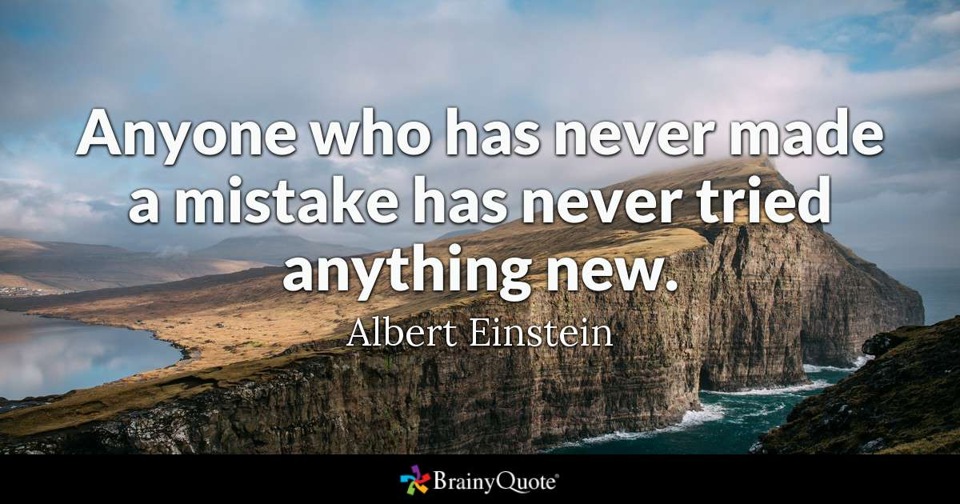

Hello Parents, My name is Kathleen Parker. I am the new Special Education Teacher here at Viborg-Hurley High School. I am new to South Dakota, moved here February, 2017 from Las Cruces, NM. I grew up in El Paso, Texas and got my first degree in Special Education from New Mexico State University. Currently, I have two master degrees as well as endorsements in English Language Literacy. I have been teaching for 10 years and very much enjoy helping our children to be successful, this is where my heart is. I am a mom of two boys ages 26 and 23 and a grandma of three, two boys and a girl.
I am excited to start this New Year with all of its challenges and new learning. In my classroom, I have both high school students and elementary at various times throughout the day. I teach Math and Reading as well as have Study Hall time in my classroom where students can work on skills they are lacking, work towards goals, finish up work for class, test, or ask any needed questions. I have three assistants who are spectacular in their contributions to both my classroom and also to the students. They are lots of help!
In my classroom, we work on skills all the way from very basic reading skills such as phonics to more advanced reading and writing. We also work on math at a very basic level to include addition and subtraction, counting money, telling time, and simple multiplication to more advanced levels of math such as Algebra 1. Students have daily work, informal assessments, participation grades, and grades for more formal testing. I offer 15 points for daily work, 10 points for informal assessments, 5 points for participation, and 20 points for formal testing for a total of 50 possible points per week. My grades are posted online for my students so feel free to look at how your son or daughter is doing in my classroom. Midterm grades were recently added. Should you have any questions, please call me here at the school, and they can ring my room.
Lastly, I would like to say thank you parents for being GREAT contributors to your child's success here at Viborg-Hurley High School!
​Ms. Parker

